**DAILY ONLINE ACTIVITIES SUMMARY**

|  |  |  |  |  |  |  |  |  |  |  |
| --- | --- | --- | --- | --- | --- | --- | --- | --- | --- | --- |
| **Date:** |  | **20-05-2020** | | |  |  |  | **Name:** | **SRILATHA K KAMATH** | |
|  |  |  |  |  |  |  |  |  |  |  |
| **Sem & Sec** |  | **6 B** | | |  |  |  | **USN:** | **4AL17CS099** | |
|  |  |  |  |  |  |  |  |  |  |  |
|  |  |  |  |  | **Online Test Summary** | | | |  |  |
|  | |  |  |  | |  |  | | |  |
| **Subject** | |  | **SYSTEM SOFTWARE AND COMPILER DESIGN IA TEST 1** | | | | | | | |
|  | |  |  |  |  |  |  | |  |  |
| **Max. Marks** | |  | **30** |  |  |  | **Score** | | **23** |  |
|  |  |  |  |  | |  |  | |  |  |
|  |  |  |  | **Certification Course Summary** | | | | | | |
|  | |  | |  | | |  | |  |  |
| **Course** |  | **Career Edge – Knockdown the Lockdown** | | | | | | |  |  |
|  |  | | |  |  |  |  | |  |  |
| **Certificate Provider** | | | | **TCS** |  |  | **Duration** | |  | **15days** |
|  |  |  |  |  |  | |  | |  |  |
|  |  |  |  |  | **Coding** | | **Challenges** | |  |  |
|  | | | | | | | | |  |  |
| **Problem Statement:** Two python programs. | | | | | | | | |  |  |
|  | | | | |  |  |  |  |  |  |
| **Status: COMPLETED** | | | | |  |  |  |  |  |  |
|  | | | | |  |  |  | |  |  |
| **Uploaded the report in Github** | | | | |  |  | **YES** | |  |  |
|  | | | | |  |  |  | | | |
| **If yes Repository name** | | | | |  |  | https://github.com/alvas-education- | | | |
|  |  |  |  |  |  |  | foundation/Srilatha-K-Kamath-Daily- | | | |
|  |  |  |  |  |  |  | Report.git | |  |  |
|  | | | | |  |  |  | |  |  |
| **Uploaded the report in slack** | | | | |  |  | **YES** | |  |  |
|  |  |  |  |  |  |  |  |  |  |  |

**Online Test Details:**

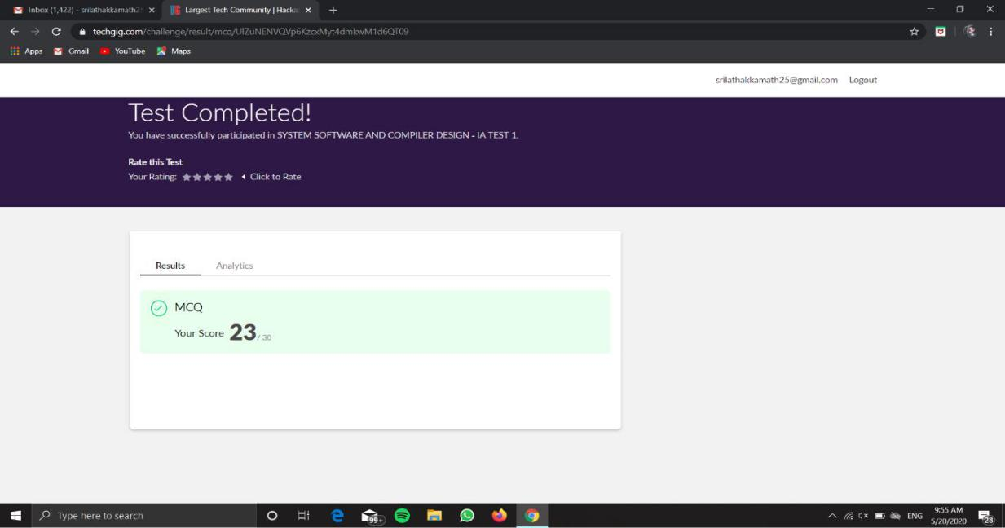

**Online Course Details: 26.79% COMPLETED.**

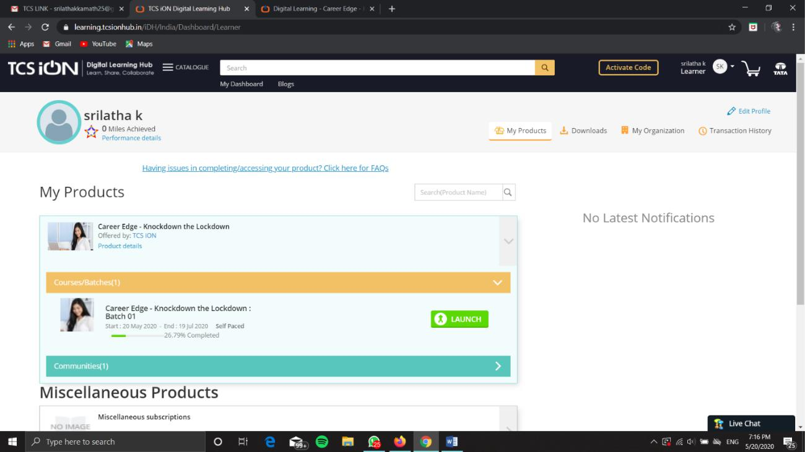

**Online Coding Details:**

